25.11 Editors - Properties Editor - Object Constraints Properties Tab
Detailled Table of content 1
Object Constraints 6
General functionality 7
Add 7
Enable / Disable 7
Remove 7
Collapse panel 8
Reorder 8
Animate Property 8
Object specific constraints 8
Motion Tracking Constraints 8
Camera Solver 8
Follow Track 9
Object Solver 10
Transform Constraints 10
Copy Location 11
Copy Rotation 12
Copy Scale 13
Copy Transforms 13
Limit Distance 14
Limit Location 15
Limit Rotation 16
Limit Scale 16
Maintain Volume 17
Volume 17
Transformation 18
Transform Cache 19
Tracking Constraints 20
Clamp To 20
Damped Track 21
Locked Track 21
Stretch To 22
Track To 24
Relationship Constraints 25
Action 25
Example: 25
Armature 27
Child Of 28
Floor 29
Follow Path 30
Shrinkwrap 32

Detailled Table of content
3.8.7- Editors - Properties Editor - Object Constraints Tab
Detailled Table of content 1
Object Constraints 6
General functionality 7
Add 7
Enable / Disable 7
Remove 7
Collapse panel 8
Reorder 8
Animate Property 8
Object specific constraints 8
Motion Tracking Constraints 8
Camera Solver 8
Active Clip 8
Constraint to F-Curve 9
Influence 9
Follow Track 9
Active Clip 9
3D Position 9
Undistorted 9
Frame Method 9
Camera 9
Depth Object 9
Constraint to F-Curve 9
Influence 9
Object Solver 10
Active Clip 10
Camera 10
Set Inverse / Clear Inverse 10
Constraint to F-Curve 10
Influence 10
Transform Constraints 10
Copy Location 11
Target 11
Bone 11
Head/Tail 11
Vertex Group 11
X, Y, Z 11
Invert 11
Offset 11
Space 11
Influence 12
Copy Rotation 12
Target 12
Bone 12
Vertex Group 12
X, Y, Z 12
Invert 12
Offset 12
Space 12
Influence 12
Copy Scale 13
Target 13
Bone 13
Vertex Group 13
X, Y, Z 13
Offset 13
Additive 13
Space 13
Influence 13
Copy Transforms 13
Target 13
Bone 14
Head/Tail 14
Space 14
Influence 14
Limit Distance 14
Target 14
Vertex Group 14
Bone 14
Head/Tail 14
Distance 14
Reset Distance 15
Clamp Region 15
Inside 15
Outside 15
Surface 15
Space 15
Influence 15
Limit Location 15
Minimum X Y Z 15
Maximum X Y Z 15
For Transform 16
Convert 16
Influence 16
Limit Rotation 16
Limit X Y Z 16
For Transform 16
Convert Space 16
Influence 16
Limit Scale 16
Minimum X Y Z 17
Maximum X Y Z 17
For Transform 17
Convert 17
Influence 17
Maintain Volume 17
Free X / Y / Z 17
Volume 17
Owner Space 17
Influence 17
Transformation 18
Target 18
Vertex Group 18
Bone 18
Extrapolate 18
Target Space 19
Owner Space 19
Influence 19
Source 19
Loc Rot Scale 19
X Y Z 19
Mapping 19
Destination 19
Loc Rot Scale 19
X Y Z 19
Mix 19
Transform Cache 19
Cache File Properties 20
Is sequence 20
Override Frame 20
Frame 20
Manual Transform Scale 20
Object Path 20
Verts/Faces/UV/Color 20
Influence 20
Tracking Constraints 20
Clamp To 20
Target 20
Main Axis 20
Cyclic 21
Influence 21
Damped Track 21
Target 21
Vertex Group 21
Bone 21
Head/Tail 21
To 21
Influence 21
Locked Track 21
Target 22
Vertex Group 22
Bone 22
Head/Tail 22
To 22
Lock 22
Influence 22
Stretch To 22
Target 22
Vertex Group 22
Bone 23
Head/Tail 23
Rest Length 23
Reset 23
Volume Min / Volume Max 23
Smooth 23
Volume 23
Plane 23
Influence 23
Track To 24
Target 24
Vertex Group 24
Bone 24
Head/Tail 24
To 24
Up 24
Target Z 24
Space 24
Influence 24
Relationship Constraints 25
Action 25
Example: 25
Target 25
Vertex Group 25
Bone 25
Influence 26
Target subpanel 26
Channel 26
Target Space 26
Target Range Min / Max 26
Action subpanel 26
Action 26
Object Action 26
Frame Start / End 26
Notes 26
Armature 27
Preserve Volume 27
Use Envelopes 27
Add Target Bone 27
Normalize Weights 27
Influence 28
Bones subpanel 28
First Edit Box 28
Second Edit Box 28
Remove Target 28
Blend Weight 28
Child Of 28
Target 28
Vertex Group 28
Bone 28
Location, Rotation, Scale 28
Set Inverse / Clear Inverse 28
Influence 29
Floor 29
Target 29
Vertex Group 29
Bone 29
Sticky 29
Use Rotation 29
Offset 29
Min / Max 29
Space 30
Influence 30
Follow Path 30
Target 30
Offset 30
Forward Axis 30
Up Axis 30
Fixed position 30
Curve Radius 31
Follow Curve 31
Forward 31
Up 31
Animate Path 31
Pivot 31
Target 31
Vertex Group 31
Bone 31
Head/Tail 31
Pivot Offset X / Y / Z 31
Rotation Range 32
Influence 32
Shrinkwrap 32
Distance 32
Shrinkwrap Mode 32
Target Normal Project 32
Nearest Vertex 32
Project 32
Project Axis 32
Space 32
Distance 32
Project Opposite 33
Face Cull 33
Invert Cull 33
Nearest Surface Point 33
Snap Mode 33
Align to Normal 33
Influence 33

Object Constraints
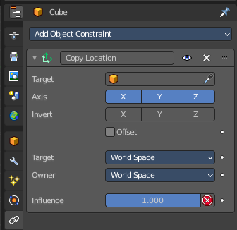
Object Constraints allows two objects to interact with each other. You can for example set the x position to the x position of another object with the Copy Location constraint.

You can have more than one constraint at an object.

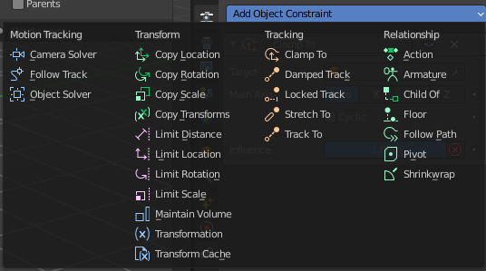
There are four groups of object constraints.
Motion Tracking constraints constraints with Motion Tracking functionality.
Transform contains constraints around everything transform related.
Tracking contains constraints around animation functionality.
And Relationship contains constraints around relations.
The different color has no deeper sense. It helps with navigating in the list of constraints.

General functionality

Add

To add a constraint to an object, simply open the drop down menu, and choose the type of constraint that you want to add.

This will add the constraint to the list.

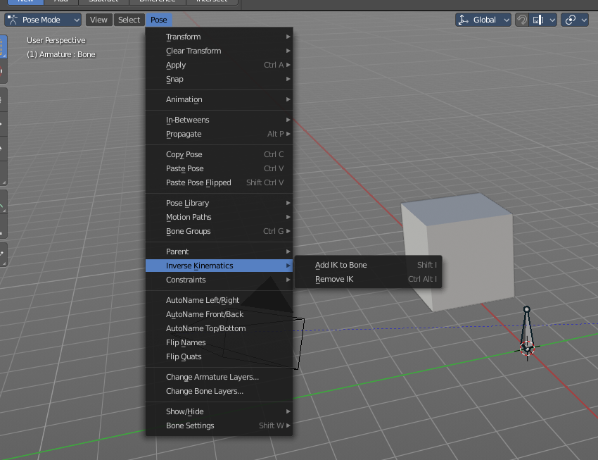
For some constraints you will also find menu items in the 3D view. The Inverse Kinematics / Add IK to Bone is such an example. It also fills in some vital information already in some cases, which you would need to choose by hand when you add the constraints in the constraint tab.

This menu entries exists to simplify the workflow. This menu entries are described in other chapters.

Enable / Disable
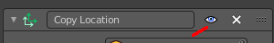
You might want to disable a constraint temporarily. This can be done by clicking at the button with the eye icon in the header. To enable the constraint simply click it again.

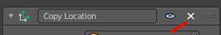
Remove
To remove a constraint from the object simply click the close button up right in the header.

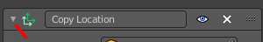
Collapse panel
The whole constraints panel can be collapsed. Click at the arrow button up left in the header.

Reorder
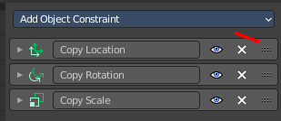
You can have more than one constraint in the list. And sometimes the order of the constraints is very important.
Grab the handler at the right and drag the constraint to the position where you want it to have.

Animate Property
Some of the properties can be animated. Click at the animate property button at the right to add a keyframe.

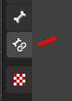
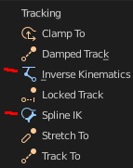
Object specific constraints
The Object Constraints tab does not contain all constraints. Some constraints are object specific. And appears in an own tab with this object selected. Bone constraints for example appears in the Bone Constraint tab.
Unfortunately you will still see the whole constraint list, and have to pick the bone constraints from there.

Motion Tracking Constraints
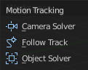
This constraints gets used in Motion Tracking.

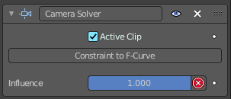
Camera Solver
The Camera Solver constraint gives the owner of this constraint, the location and rotation of the «solved camera motion».
The «solved camera motion» is where Blender reconstructs the position of the physical, real-world camera, when it filmed the video footage, relative to the thing being tracked.
Note: This constraint only works after you have set up a minimum of eight markers and pressed Solve Camera Motion. See motion tracking chapter.

Active Clip
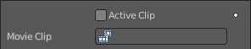
Receive tracking data from the active clip in the Movie Clip editor. If unchecked, an option appears to choose from the other clips.

Constraint to F-Curve
Applies the constraint, and creates Keyframes for the transforms.

Influence
The influence level of this constraint.

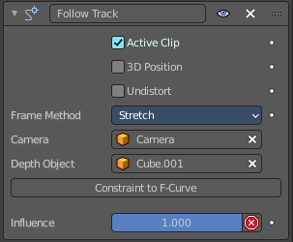
Follow Track
This constraint makes objects have the same position at a frame as the track has. The motion of this object happens on a single plane defined by the camera and the original position of the object.

Active Clip
Receive tracking data from the active movie clip in the Movie Clip editor. If unchecked, an option appears to choose from the other available clips.

3D Position
Use the 3D position of the track to parent to.

Undistorted
Parent to the undistorted position of the 2D track.

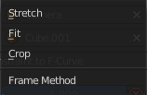
Frame Method
Defines how the footage is fitted in the camera frame.

Camera
Select the camera to which the motion is parented to (if active an empty scene camera is used).

Depth Object
If this object is set, constrained objects will be projected onto the surface of this depth object which can be used to create facial makeup visual effects.

Constraint to F-Curve
Creates F-Curves for the object that copies the movement caused by the constraint.

Influence
The influence level of this constraints.

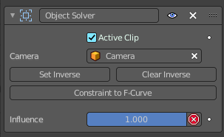
Object Solver
The Object Solver constraint gives the owner of this constraint, the location and rotation of the «solved object motion».
This can be used to add a mesh to video for example.
Note: This constraint only works after you have set up a minimum of eight markers and pressed Solve object Motion.
If it says Solve Camera Motion instead of Solve Object Motion then go into the Movie Clip Editor > Properties region > Objects and switch it from the camera, to an object.

Active Clip
Receive tracking data from the active movie clip in the Movie Clip editor. If unchecked, an option appears to choose from the other available clips.

Camera
Here you can choose the camera.

Set Inverse / Clear Inverse
Set the connection for the object solver constraint inverse.
Clear the inversion.

Constraint to F-Curve
Creates F-Curves for the object that copies the movement caused by the constraint.

Influence
The influence level of this constraint.

Transform Constraints
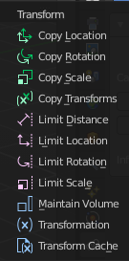
This category contains transform constraints.

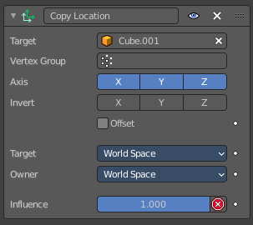
Copy Location
The Copy Location constraint sets the position to the position of the target object.

Warning
Using this constraint on a connected bone will have no effect. Because it is the parent’s tip which controls the position of your owner bone’s root.

Target
Here you can choose the target object to copy the location from.

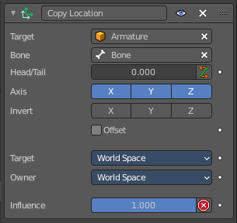
Bone
If the Target is an Armature, then you have the optional choice to set an individual bone as Target.

Head/Tail
If the target is a bone, then here you can adjust where along this bone the target point lies.

Vertex Group
If the Target is a Mesh, then you have the optional choice to set a Vertex Group as target.

X, Y, Z
Here you can choose which axes to constraint.

Invert
Inverts the coordinate input. Positive becomes negative, and vice versa.

Offset
Add an offset from the original position to the target position.

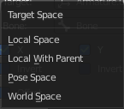
Space
Here you can choose the target space and its coordinate system to use for calculation. The local space uses local axis, the world space global axis ...

Influence
The influence level of this constraint.

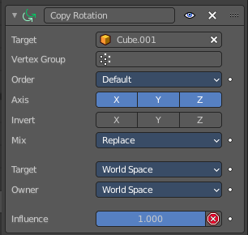
Copy Rotation
The Copy Rotation constraint sets the rotation to the rotation of the target object.

Target
Here you can choose the target object to copy the rotation from.

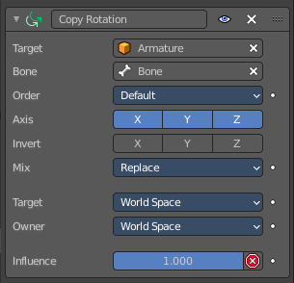
Bone
If the Target is an Armature, a new field is displayed offering the optional choice to set an individual bone as Target.

Vertex Group
If the Target is a Mesh, a new field is displayed offering the optional choice to set a Vertex Group as target.

X, Y, Z
These buttons control which axes are constrained - by default, all three are on.

Invert
Inverts the coordinate input. Positive becomes negative, and vice versa.

Offset
Add an offset from the original position to the target position.

Space
Here you can choose the target space and its coordinate system to use for calculation. The local space uses local axis, the world space global axis ...

Influence
The influence level of this constraint.

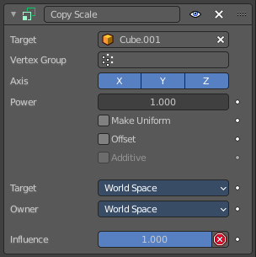
Copy Scale
The Copy Scale constraint sets the size to the size of the target object.

Target
Here you can choose the target object to copy the size from.

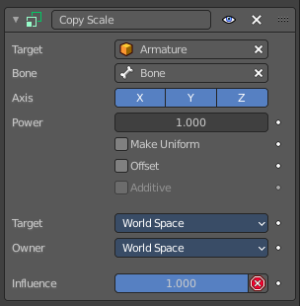
Bone
If Target is an Armature, a new field is displayed offering the optional choice to set an individual bone as Target.

Vertex Group
If Target is a Mesh, a new field is displayed offering the optional choice to set a Vertex Group as target.

X, Y, Z
These buttons control which axes are constrained - by default, all three are on.

Offset
Add an offset from the original scale to the target scale.

Additive
Use Addition instead of Multiplication to combine scale. This is a compatibility feature to Blender 2.79 and Bforartists 1

Space
Here you can choose the target space and its coordinate system to use for calculation. The local space uses local axis, the world space global axis ...

Influence
The influence level of this constraint.

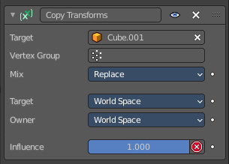
Copy Transforms
The Copy Transform constraint copies the whole transform values from the target object. Location, Rotation and Scale.

Target
Here you can choose the target object to copy the location from.

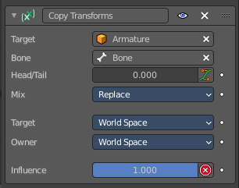
Bone
If the Target is an Armature, a new field is displayed offering the optional choice to set an individual bone as Target.

Head/Tail
If the target is a bone, then here you can adjust where along this bone the target point lies.

Space
Here you can choose the target space and its coordinate system to use for calculation. The local space uses local axis, the world space global axis ...

Influence
The influence level of this constraint.

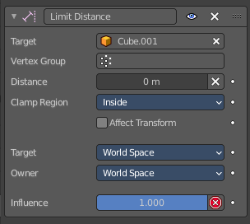
Limit Distance
The Limit Distance constraint constraints either outside, inside, or at the surface of a sphere centered at the target object.

Target
Here you can choose the target object.

Vertex Group
If Target is a Mesh, a new field is displayed offering the optional choice to set a Vertex Group as target.

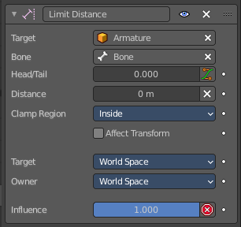
Bone
If the Target is an Armature, a new field is displayed offering the optional choice to set an individual bone as Target.

Head/Tail
If the target is a bone, then here you can adjust where along this bone the target point lies.

Distance
This numeric field sets the limit distance, i.e. the radius of the constraining sphere.

Reset Distance
When clicked, this small button will reset the Distance value, so that it corresponds to the actual distance between the owner and its target (i.e. the distance before this constraint is applied).

Clamp Region
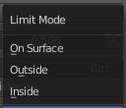
The Limit Mode drop-down menu allows you to choose how to use the sphere defined by the Distance setting and target’s center:

Inside
The owner is constrained inside the sphere.

Outside
The owner is constrained outside the sphere.

Surface
The owner is constrained on the surface of the sphere.

Space
Here you can choose the target space and its coordinate system to use for calculation. The local space uses local axis, the world space global axis ...

Influence
The influence level of this constraint.

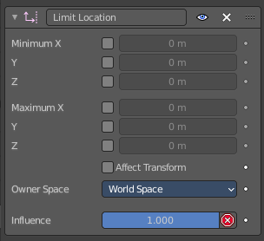
Limit Location
This constraint restricts the amount of allowed translations along each axis, through lower and upper bounds.
The limits for an object are calculated from its center. Te limits of a bone are calculated from its root.

Minimum X Y Z
Restrict the minimum location. You can adjust the value in the edit box below.

Maximum X Y Z
Restrict the maximum location. You can adjust the value in the edit box below.

For Transform
The constraint limits the location. The values in the transform panel can still change above this limit though. With this option ticked the transform values are also clamped.

Convert
Calculate the constraint in local space or world space.

Influence
The influence level of this constraint.

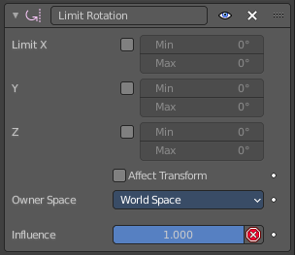
Limit Rotation
This constraint restricts the amount of allowed rotation along each axis, through lower and upper bounds.
The limits for an object are calculated from its center. Te limits of a bone are calculated from its root.

Limit X Y Z
Restrict the rotation. You can adjust the minimum and maximum value in the edit boxes below.

For Transform
The constraint limits the rotation. The values in the transform panel can still change above this limit though. With this option ticked the transform values are also clamped.

Convert Space
Calculate the constraint in local space or world space.

Influence
The influence level of this constraint.

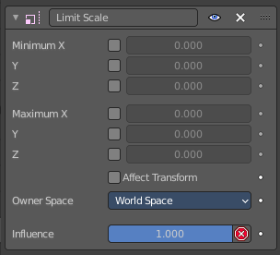
Limit Scale
This constraint restricts the amount of allowed scale along each axis, through lower and upper bounds.
The limits for an object are calculated from its center. Te limits of a bone are calculated from its root.

Minimum X Y Z
The minimum size. You can adjust the value in the edit boxes below.

Maximum X Y Z
The maximum size. You can adjust the value in the edit boxes below.

For Transform
The constraint limits the location. The values in the transform panel can still change above this limit though. With this option ticked the transform values are also clamped.

Convert
Calculate the constraint in local space or world space.

Influence
The influence level of this constraint.

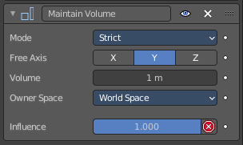
Maintain Volume
The Maintain Volume constraint limits the volume of a mesh or a bone to a given ratio of its original volume.

Free X / Y / Z
The free-scaling axis of the object.

Volume
The bone’s rest volume.

Owner Space
Calculate the constraint in local space or world space.

Influence
The influence level of this constraint.

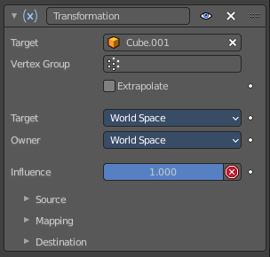
Transformation
The Transformation constraint allows you to map one type of transform properties (i.e. location, rotation or scale) of the target, to the same or another type of transform properties of the owner, within a given range of values.

Warning
Note that:
- When mapping transform properties to location (i.e. Loc, Destination button is enabled), the owner’s existing location is added to the result of evaluating this constraint (exactly like when the Offset button of the Copy Location constraint is enabled...).
- Conversely, when mapping transform properties to rotation or scale, the owner’s existing rotation or scale is overridden by the result of evaluating this constraint.
- When using the rotation transform properties of the target as input, whatever the real values are, the constraint will always “take them back” into the -180, 180 range (e.g. if the target has a rotation of 420 around its X axis, the values used as X input by the constraint will be ((420 + 180) modulo 360) - 180 = 60- ...). This is why this constraint is not really suited for gears!
- Similarly, when using the scale transform properties of the target as input, whatever the real values are, the constraint will always take their absolute values (i.e. invert negative ones).
- When a min value is higher than its corresponding max one, both are considered equal to the max one. This implies you cannot create “reversed” mappings...

Target
Here you can choose the target object.

Vertex Group
If the Target is a Mesh, a new field is displayed offering the optional choice to set a Vertex Group as target.

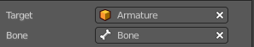
Bone
If the Target is an Armature, a new field is displayed offering the optional choice to set an individual bone as Target.

Extrapolate
With this option enabled the min and max values are no longer strict limits, but rather “markers” defining a proportional (linear) mapping between input and corresponding output values.

Target Space
Space that the target is evaluated in.

Owner Space
Space that owner is evaluated in.

Influence
The influence level of this constraint.

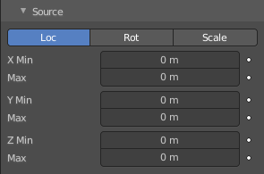
Source

Loc Rot Scale
A tab to switch between the available location, rotation and scale values.

X Y Z
The transform values. Here you can edit the minimum and maximum values for the source object.

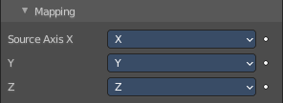
Mapping
Map specific axis to other axis than the source object.

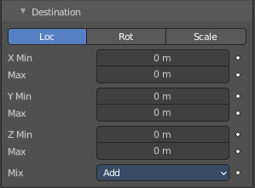
Destination

Loc Rot Scale
A tab to switch between the available location, rotation and scale values.

X Y Z
The transform values. Here you can edit the minimum and maximum values for the source object.

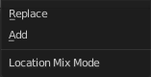
Mix
The location mix mode.

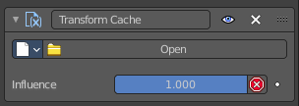
Transform Cache
The Transform Cache Constraint is used to be able to stream animations made at the transformation matrix level (for example rigid bodies, or camera movements). You need an alembic file with the animation. - And i have unfortunately no idea how to produce the required file. Thanks Blender manual writers!

Cache File Properties
Here you can select the Alembic file.

Is sequence
If the file is a series of files.

Override Frame
Whether to use a custom frame for looking up data in the cache file, instead of using the current scene frame.

Frame
The time to use for looking up the data in the cache file, or to determine which to use in a file sequence.

Manual Transform Scale
Value by which to enlarge or shrink the object with respect to the world’s origin.

Object Path
The path to the Alembic object inside the archive.

Verts/Faces/UV/Color
Type of data to read for a mesh object respectively: vertices, polygons, UV layers and Vertex Color layers.

Influence
The influence level of this constraint.

Tracking Constraints
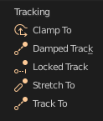

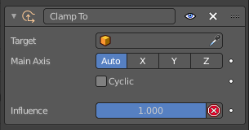
Clamp To
The Clamp To constraint clamps an object to a curve. So you need a curve object as the target.

Target
Here you can choose the target object.

Main Axis
Auto clamps to all three axis. X , Y, Z maps just to one axis,.

Cyclic
With cyclic enabled the object will jump from end point to start point once it has reached the end.

Influence
The influence level of this constraint.

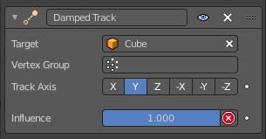
Damped Track
Damped track makes the object always look at the target object. For example a camera always looking at an armature

Target
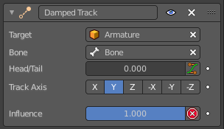
Here you can choose the target object.

Vertex Group
If the Target is a Mesh, a new field is displayed offering the optional choice to set a Vertex Group as target.

Bone
If the Target is an Armature, a new field is displayed offering the optional choice to set an individual bone as Target.

Head/Tail
If the target is a bone, then here you can adjust where along this bone the target point lies.

To
The axis to use to point towards the target object. For a camera you might want to use -Z

Influence
The influence level of this constraint.

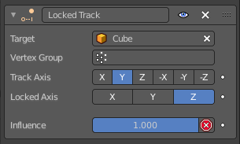
Locked Track
Similar to Damped Track. Locked track makes the object always look at the target object. For example a camera always looking at an armature. But here you can lock single axis.
Note, you cannot lock the axis where you look at. The constraint will show the name red then.

Target
Here you can choose the target object.

Vertex Group
If the Target is a Mesh, a new field is displayed offering the optional choice to set a Vertex Group as target.

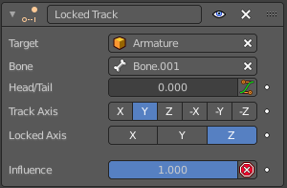
Bone
If the Target is an Armature, a new field is displayed offering the optional choice to set an individual bone as Target.

Head/Tail
If the target is a bone, then here you can adjust where along this bone the target point lies.

To
The axis to use to point towards the target object. For a camera you might want to use -Z

Lock
The axis that you want to lock.

Influence
The influence level of this constraint.

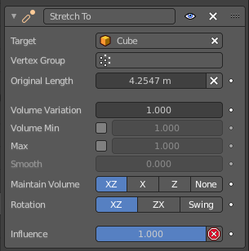
Stretch To
Stretch To makes the object always look at the target object. For example a cube always looking at another cube. And makes it stretch when the distance changes.
With bones, the “volumetric” variation scales them along their own local axes (remember that the local Y axis of a bone is aligned with it, from root to tip).

Target
Here you can choose the target object.

Vertex Group
If the Target is a Mesh, a new field is displayed offering the optional choice to set a Vertex Group as target.

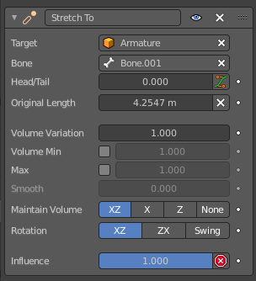
Bone
If the Target is an Armature, a new field is displayed offering the optional choice to set an individual bone as Target.

Head/Tail
If the target is a bone, then here you can adjust where along this bone the target point lies.

Rest Length
Here you can define the rest distance between the owner and its target. The rest length is the distance at which there is no deformation (stretching) of the owner.

Reset
Resets the Rest Length.

Volume Min / Volume Max
Here you can control the amount of “volume” variation proportionally to the stretching amount. Note that the 0.0 value is not allowed.

Smooth
Strength of volume stretching clamping.

Volume
Here you can adjust which of the X and/or Z axes should be affected to preserve the virtual volume while stretching along the Y axis. The NONE button disables the volumetric features.

Plane
Here you can control which of the X or Z axes should be as much as possible aligned with the global Z axis, while tracking the target with the Y axis.

Influence
The influence level of this constraint.

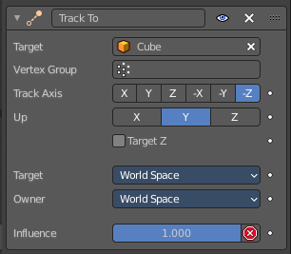
Track To
Track To makes the object always look at the target object. For example a cube always looking at another cube. Or a camera looking at a mesh.

Target
Here you can choose the target object.

Vertex Group
If the Target is a Mesh, a new field is displayed offering the optional choice to set a Vertex Group as target.

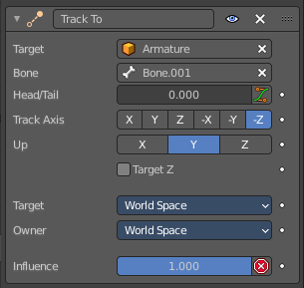
Bone
If the Target is an Armature, a new field is displayed offering the optional choice to set an individual bone as Target.

Head/Tail
If the target is a bone, then here you can adjust where along this bone the target point lies.

To
The axis to use to point towards the target object.

Up
The axis that points upwards

Target Z
Constrain the UP direction to the target's Z axis instead of the World Z Axis.

Space
Here you can choose the target space and its coordinate system to use for calculation. The local space uses local axis, the world space global axis ...

Influence
The influence level of this constraint.

Relationship Constraints
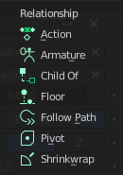

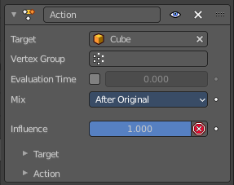
Action
The Action constraints allows you control an Action using the animated transformations of another object. For example move a cube when another cube moves by animation, without the need to record this movement by a keyframe. There needs to be an animation in the scene, not necessarily at the target object, which is used as the Action for the constraint.
The constraint accepts the Mesh action type. But only the Object, Pose and Constraint types are really working, since constraints can only affect objects’ or bones’ transform properties, and not meshes’ shapes.
Only the object transformation (location, rotation, scale) is affected by the action. Keyframes for other properties are ignored. The constraints does not influence them.

Example:
Create a cube. Animate it to create the needed action. Move from a to b for example. And record the keyframes. This will create an action that is now available to the constraint.
Moving the target in the [0.0, 2.0] range along its X axis maps the action content on the owner in the [0, 100] frame range. This will mean that when the target’s X property is 0.0 the owner will be as if in frame 0 of the linked action. With the target’s X property at 1.0 the owner will be as if in frame 50 of the linked action, etc.

Target
Here you can choose the target object.

Vertex Group
If the Target is a Mesh, a new field is displayed offering the optional choice to set a Vertex Group as target.

Evaluation Time
Interpolate between action start and endframe by using the slider value.

Bone
If the Target is an Armature, a new field is displayed offering the optional choice to set an individual bone as Target.

Influence
The influence level of this constraint.

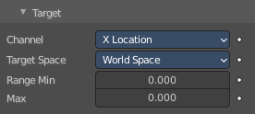
Target subpanel

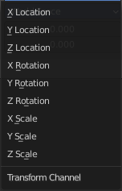
Channel
The transform channel allows you to choose in which space to evaluate its target's transform properties.

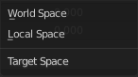
Target Space
The space in which the target is transformed in.

Target Range Min / Max
The lower and upper bounds of the driving transform property value. By default, both values are set to 0.0
Note:
• When using a rotation property as “driver”, these values are “mapped back” to the -180.0 , 180.0 range.
• When using a scale property as “driver”, these values are limited to null or positive values.

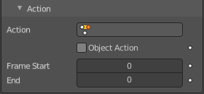
Action subpanel

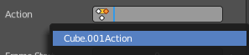
Action
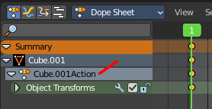
Here you can choose the action that you want to use. Available actions appears in the drop down list.

Object Action
This is for bones only. This option will make the constrained bone use the “object” part of the linked action, instead of the “same-named pose” part. This allows you to apply the action of an object to a bone.

Frame Start / End
The starting and ending frames of the action to be mapped.
Note:
• These values must be strictly positive.
• By default, both values are set to 0 which disables the mapping (i.e. the owner just gets the properties defined at frame 0 of the linked action...).

Notes
- When the linked action affects some location properties, the owner’s existing location is added to the result of evaluating this constraint (exactly as when the Offset button of the Copy Location constraint is enabled...).
- When the linked action affects some scale properties, the owner’s existing scale is multiplied with the result of evaluating this constraint.
- When the linked action affects some rotation properties, the owner’s existing rotation is overridden by the result of evaluating this constraint.
- Unlike usual, you can have a Start value higher than the End one, or a Min one higher than a Max one: this will reverse the mapping of the action (i.e. it will be “played” reversed...), unless you have both sets reversed, obviously!
- When using a Constraint action, it is the constraint channel’s names that are used to determine to which constraints of the owner apply the action. E.g. if you have a constraint channel named “trackto_empt1”, its keyed Influence and/or Head/Tail values (the only ones you can key) will be mapped to the ones of the owner’s constraint named “trackto_empt1”.
- Similarly, when using a Pose action (which is obviously only meaningful and working when constraining a bone!), it is the bone’s name that is used to determine which bone channel’s names from the action to use (e.g. if the constrained bone is named “arm”, it will use and only use the action’s bone channel named “arm”...). Unfortunately, using a Pose action on a whole armature object (to affect all the keyed bones in the action at once) won’t work...
- Note also that you can use the pose library feature to create/edit a Pose action data-block... just remember that in this situation, there’s one pose per frame!

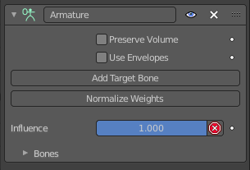
Armature
Armature is the constraint version of the Armature Modifier. It reproduces the weight-blended bone transformations and applies it to its owner orientation. It can be used like a variant of the Child Of constraint that can handle multiple parents at once, but requires all of them to be bones.

Preserve Volume
Tries to preserve the volume when deforming the mesh.

Use Envelopes
Multiply the weights by envelope for all bones instead of vertex group based blending. The specified weights are still used, and only the listed bones are considered.

Add Target Bone
Add a target bone. By clicking two edit boxes becomes available. You can add multiple armatures and bones here.

Normalize Weights
Normalize the weights of all target bones.

Influence
The influence level of this constraint.

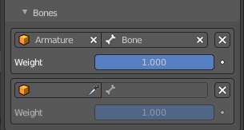
Bones subpanel
When you ad a bone with the Add Target Bone, then you create a property in this panel.

First Edit Box
Here you select the armature.

Second Edit Box
Here you select the bone.

Remove Target
Remove the target. Resets Add Target Bone.

Blend Weight
Blending Weight of this bone.

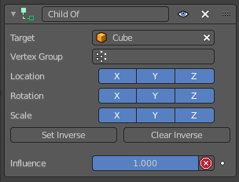
Child Of
This constraints allows you to set a parent to this object. By using more than one constraint you can have more than one parent object here, and control the influence by the Influence slider. You can also just parent the movement of a specific axis.

Target
Here you can choose the target object.

Vertex Group
If the Target is a Mesh, a new field is displayed offering the optional choice to set a Vertex Group as target.

Bone
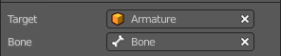
If the Target is an Armature, a new field is displayed offering the optional choice to set an individual bone as Target.

Location, Rotation, Scale
Activate the parenting for the corresponding axis.

Set Inverse / Clear Inverse
Set the connection for the object solver constraint inverse.
Clear the inversion.

Influence
The influence level of this constraint.

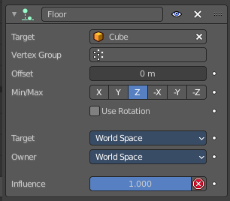
Floor
The Floor constraints allows to set an object as a floor or wall that cannot be passed by the object.
Note that the center of the object is calculated as the collision point, not the surface. Means a cube with the pivot in the center can still sink half into a ground plane. This can be adjusted with the Offset value.

Target
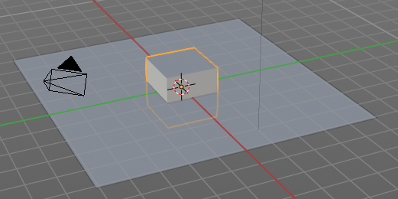
Here you can choose the target object.

Vertex Group
If the Target is a Mesh, a new field is displayed offering the optional choice to set a Vertex Group as target.

Bone
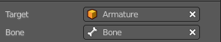
If the Target is an Armature, a new field is displayed offering the optional choice to set an individual bone as Target.

Sticky
The object sticks at its position at contact. For example, it cannot slide around on the surface of a plane any more.

Use Rotation
Take the target’s rotation into account. This allows you to have a “floor” plane of any orientation you like, not just the global XY, XZ and YZ ones...

Offset
Here you can define an offset from the pivot to the ground plane object.

Min / Max
Here you define which side of the target object will be the floor.
By default, these normals are aligned with the global axes. If you enable Use Rotation (see above), they will be aligned with the local target’s axes.

Space
Here you can choose the target space and its coordinate system to use for calculation. The local space uses local axis, the world space global axis ...

Influence
The influence level of this constraint.

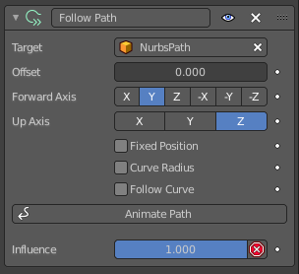
Follow Path
Makes the object follow a curve path. This constraint requires a Bezier or Nurbs Curve. Follow Path is an animation only constraint.
The movement happens in the global world.

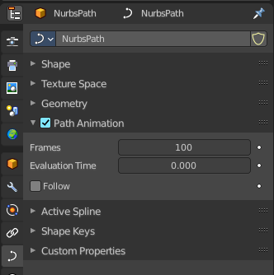
Click at Animate Path to create the animation. When you play the animation, then the object will move along the path now. The path length can be adjusted in the Path Animation panel of the curve. Here you can see that the value behind evaluation time is now green. And there is a keyframe symbol behind the edit box. Adjust the number of frames to your needs.

Target
Choose the target path.

Offset
The number of frames to offset from the “animation” defined by the path. It starts by default from frame 1.

Forward Axis
The axis that points forward at the path.

Up Axis
The axis that points upwards.

Fixed position
Object will stay locked to a single point somewhere along the length of the curve regardless of time.

Curve Radius
Objects scaled by the curve radius. See Curve Editing.

Follow Curve
When this option is activated, the owner’s rotation is modified by:

Forward
The axis of the object that has to be aligned with the forward direction of the path (i.e. tangent to the curve at the owner’s position).

Up
The axis of the object that has to be aligned (as much as possible) with the world Z axis. In fact, with this option activated, the behavior of the owner shares some properties with the one caused by a Locked Track constraint, with the path as “axle”, and the world Z axis as “magnet”.

Animate Path
Add a default animation for the path constraint if it is not animated already.

Pivot
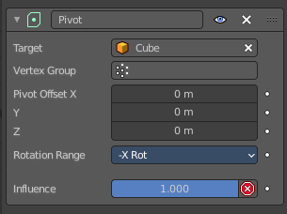
The Pivot constraint allows the owner to rotate around a target object.

Target
Here you can choose the target object.

Vertex Group
If the Target is a Mesh, a new field is displayed offering the optional choice to set a Vertex Group as target.

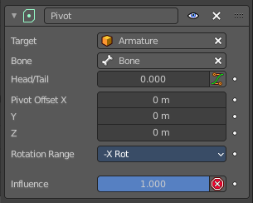
Bone
If the Target is an Armature, a new field is displayed offering the optional choice to set an individual bone as Target.

Head/Tail
If the target is a bone, then here you can adjust where along this bone the target point lies.

Pivot Offset X / Y / Z
Here you can adjust an offset.

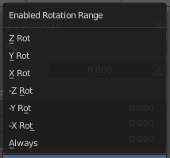
Rotation Range
Enable rotation range for specific axis.

Influence
The influence level of this constraint.

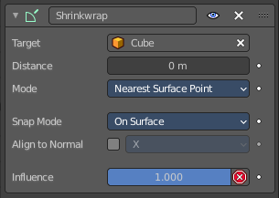
Shrinkwrap
The Shrinkwrap constraint allows you to snap objects to the surface of mesh objects. The target object has to be a Mesh object. Other object types does not work.
The snap point is the pivot point of the object.

Distance
Here you can adjust an offset.

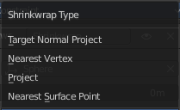
Shrinkwrap Mode
Here you can choose between different shrink-wrap methods.

Target Normal Project
Target the nearest target surface along the interpolated vertex normals of the target.

Nearest Vertex
Target the nearest vertex at the target.

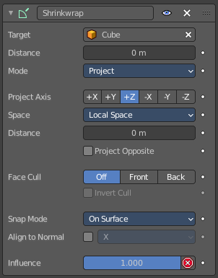
Project
Target the nearest surface point along a given axis.

Project Axis
Here you can define the axis

Space
Here you can define the space that gets used for this axis.

Distance
Limit the distance used for projection. Zero disables the Project Distance.

Project Opposite
Project in both specified and opposite directions.

Face Cull
Stop vertices from projecting to a face on the target when facing towards or away.

Invert Cull
Invert the face cull mode.

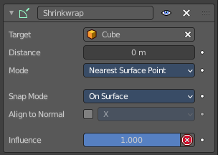
Nearest Surface Point
Target the nearest surface point.

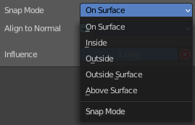
Snap Mode

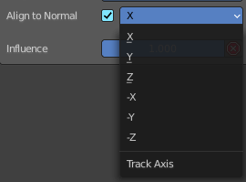
Align to Normal
Align a specified axis to the surface normal.

Influence
The influence level of this constraint.

